LAB 04

Tasks Related to Arithmetic Operators
- Write a Python program to take two numbers as input and perform all arithmetic operations on them.
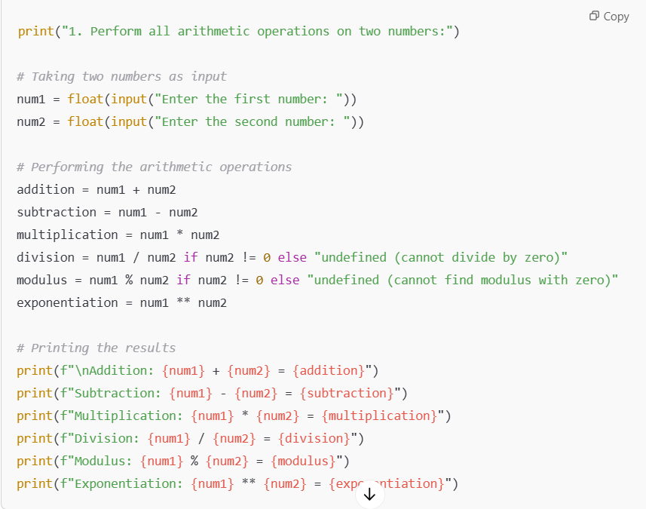
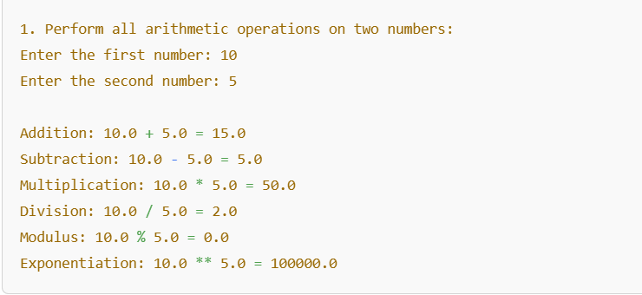

- Create a function that takes two numbers and returns their sum, difference, product, and quotient.
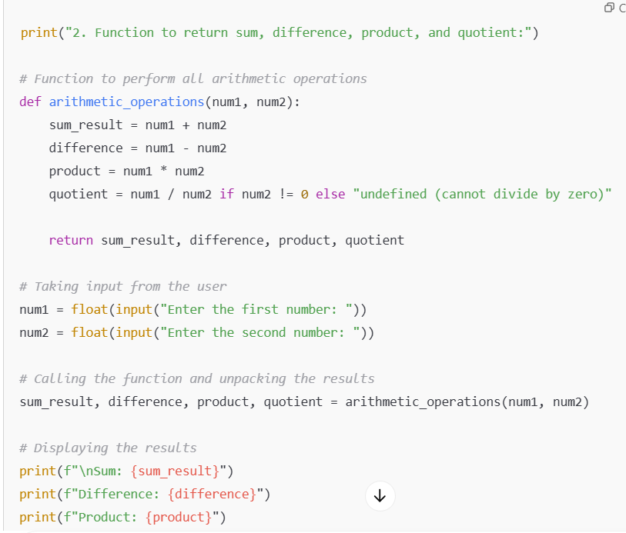
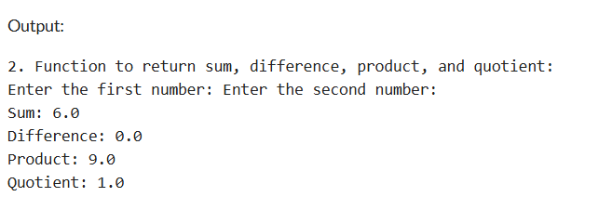

- Write a Python script to find the remainder when one number is divided by another.
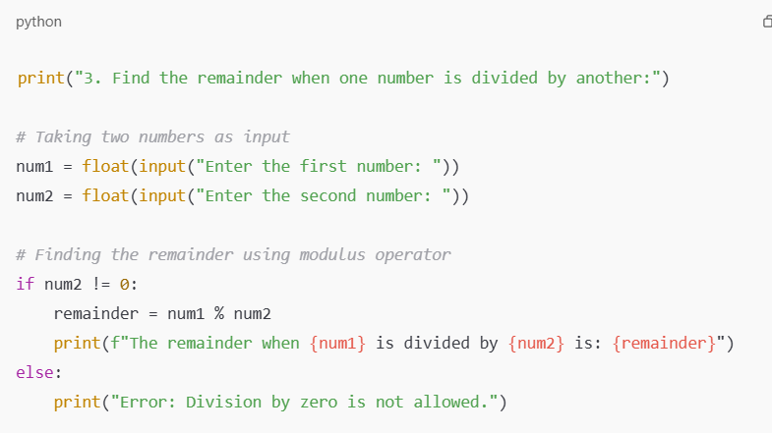
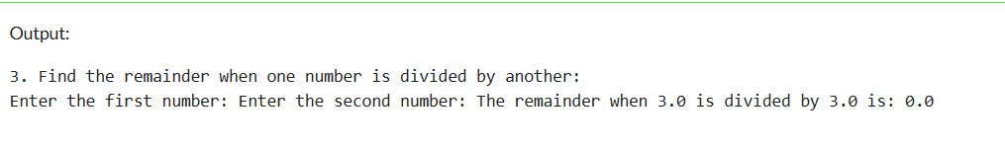

- Write a program to calculate the area of a circle using the formula: Area = π * r^2.
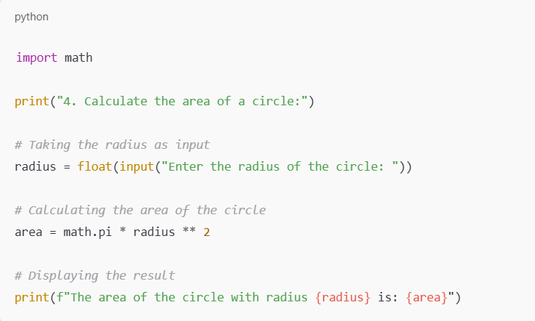
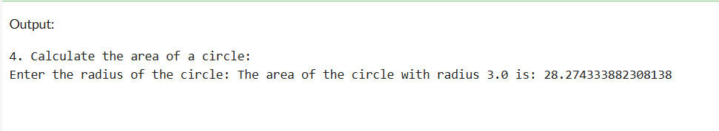

- Implement a program that takes a number as input and returns its square and cube using exponentiation.
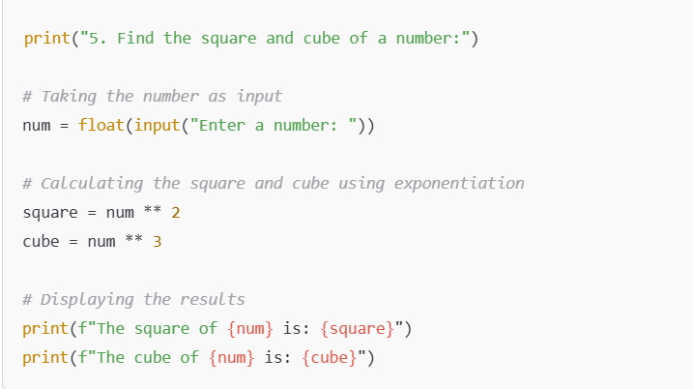
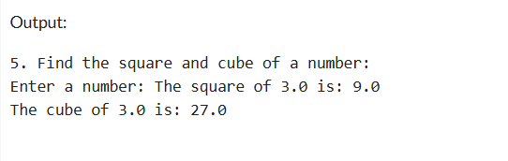

- Create a simple calculator in Python that allows the user to choose an operation (addition, subtraction, etc.) and inputs two numbers.
